# CS 255 System Design Document Template

This template lays out all the different sections that you need to complete for Project Two. Each section has guidance to prompt your thinking. You will need to continually reference the interview transcript as you work to make sure that you are addressing your client’s needs. There is no required length for the final document. Instead the goal is to complete each section based on what your client’s needs are. Remove this note when you are finished, and replace all bracketed text with the relevant information.

## UML Diagrams

### UML Use Case Diagram

*[In Module Six, you were asked to complete a use case diagram based on your system design. If you would like to make any adjustments to your diagram, please do so. Please insert your use case diagram here. Check to make sure that you included appropriate components and symbols and that your design meets the client’s needs.]*

### UML Activity Diagrams

*[You were asked to choose* ***two*** *use cases and create* ***two*** *activity diagrams, one for each use case. Please insert* ***both*** *of your activity diagrams here. Check to make sure that you included appropriate components and symbols and that your design meets the client’s needs.]*

**Use Case: Purchase Packages**

**Use Case: Login**

### UML Sequence Diagram

*[You were asked to create a sequence diagram based on* ***one*** *of the use cases you chose. Please insert your sequence diagram here. Check to make sure that you included appropriate components and symbols and that your design meets the client’s needs.]*

**Use Case: Purchase Packages**

### UML Class Diagram

*[You were asked to create a class diagram based on the different classes and attributes needed for your system design. You are* ***not*** *required to include methods, but you may if you wish. Please insert your class diagram here. Check to make sure that you included appropriate components and symbols and that your design meets the client’s requirements.]*

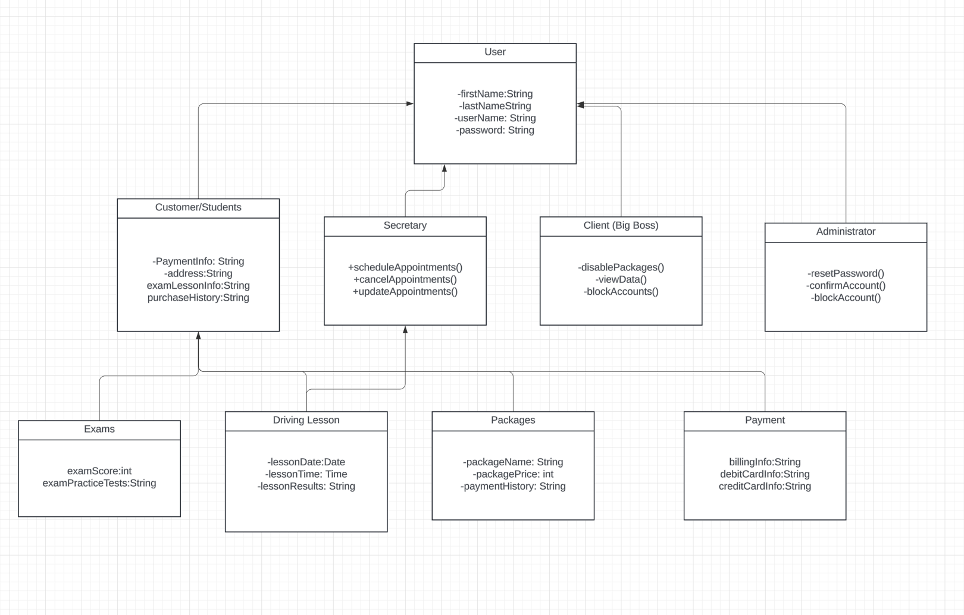

## Technical Requirements

*[Based on the diagrams you have created, describe the technical requirements of your system. These requirements should address the required hardware, software, tools, and infrastructure necessary for your system design.]*

**System can run on all platforms such as Unix, Apple, Windows, etc.**

**Users have there own unique login information**

**Latest security systems for the client and the server.**

**Regular system updates to keep systems fresh and working well.**

**Validate user credentials on DriverPass website.**

**Validate user payments on DriverPass website.**

**Users can access DriverPass though mobile devices like phones, tablets, laptops, etc.**

**The system runs on a cloud based back-end to store system and user information.**

**Maintain regular consistent updates**

**The information can be accessed offline for the administrator**

**Have scheduled updates when DMV modify there guidelines/policies**

**Allow user’s to have password resets, logins, and any requests**

**Purchasable packages on the web-based platform**

**Compatible with all support browsers like Safari, Firefox, Google, etc.**

**User Lucid Chart for the tools to make UML diagrams like sequence, class, use-case, and activity**

**High Speed connections with stable internet**